Long Method Code Smell

Location: src/main/java/org/jabref/gui/openoffice/OOBibBase

This class has a method called refreshCiteMarkersInternal() which has more than 200 lines of code.

Begging of the method:

End of the method:

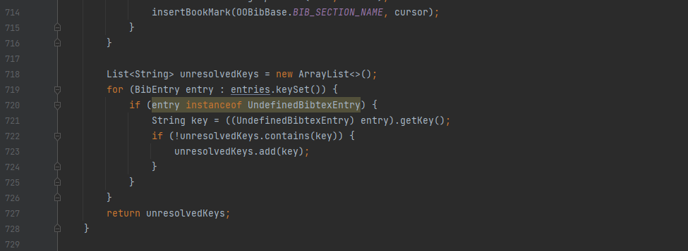

Even though the method has some comments explain what it is doing, if it was broken up in to smaller methods maybe every time it does a cycle like in the snippet each with their own description then this code would be easier to read.